MICROPLASTICS IN THE MARINE ENVIRONMENT: IMPLICATIONS ON COMMERCIALLY IMPORTANT FISH AND INVERTEBRATE SPECIES OF THE EASTERN AEGEAN SEA.
DAINES-RAVN A. V. ¹, FARAGGIANA E. ², pietroluongo G ³, quintana B. ³, milIou A. ³
¹ Erhvervsakademi Aarhus: Sønderhøj 30, 8260 Viby, Denmark
² University of Plymouth, Drake Circus, Devon PL4 8AA, United Kingdom
³ Archipelagos Institute of Marine Conservation, P.O. Box 42 Pythagorio 83 103 Samos, Greece
Key words: Microplastics, Pollution, Water column, Marine trophic chain, Aegean Sea
As the occurrence of microplastics in the marine environment has increased over the decades, concerns about the effects of this contaminant on ecosystem functions and human health have grown as current knowledge is limited. The purpose of this study is to offer an assessment into microplastics and their distribution throughout the marine trophic chain. The gastrointestinal tracts of 63 marine specimens were collected and analysed between the months of February-April 2018. All species analysed inhabited different water columns across the eastern coast of Samos Island, in the Eastern Aegean Sea. These included eight commercially important fish species (Sparus aurata, Sarda sarda, Sphyraena viridensis, Boops boops, Diplodus annularis, Serranus cabrilla, Trachurus mediterraneus, Mullus barbatus) as well as four invertebrate species (Paracentrotus lividus, Todarodes sagittatus, Parapenaeus longirostris, Ostrea edulis). All individuals exhibited microplastic contamination, with a total of 2,446 microplastic items identified among the 63 examined specimens. The abundance and prevalence of different types of microplastics were compared throughout all specimens collected. Plastic fibres were ubiquitous throughout all samples analysed and accounted for 67% of all microplastics detected in this study. A significant variation in microplastic abundance across four main water column levels was recorded (Figure 1), with semipelagic, omnivorous fish species reporting a consistently higher number of microplastic items than both demersal fish and benthic invertebrate species (one-way ANOVA: F(3,19) = 4.970, p = 0.010). The results of this study prove the persistence of microplastics throughout the marine trophic web. Since three billion people rely on the ocean as their primary source of protein, it is crucial to spur further research efforts to investigate the unknown consequences of microplastic contaminants. Such pollutants can serve as vectors and aid in the transference of harmful chemicals, emphasising the need of more sustainable alternatives in order to safeguard marine life as well as the health of seafood consumers.
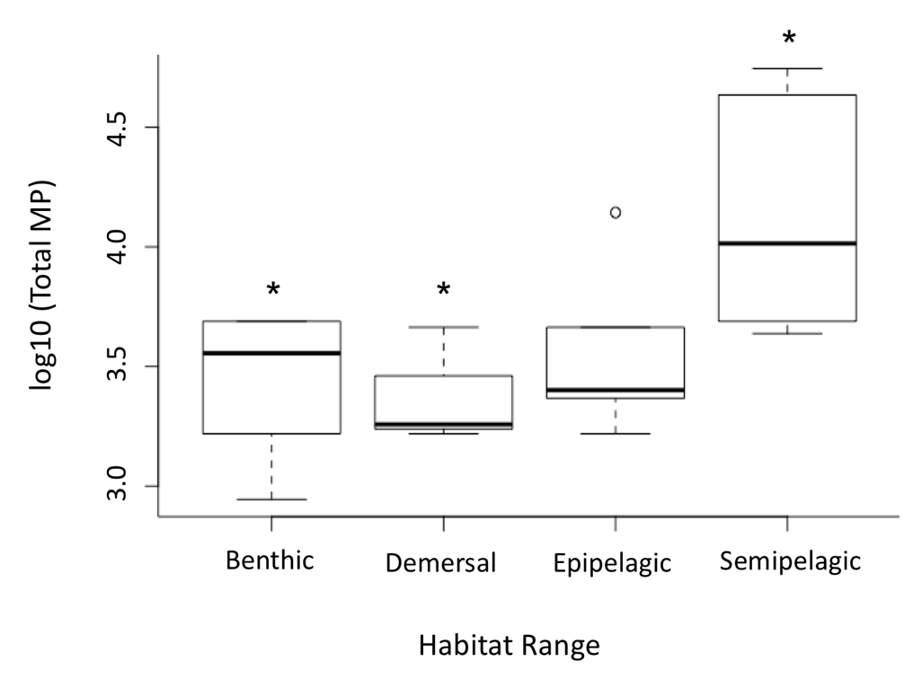
Figure 1. Differences in the amount of total microplastics (total MP) across different habitat ranges. Asterisks on boxplots indicate where the levels of significance lie. Semipelagic, omnivorous fish species show a significantly higher number of microplastic items than demersal fish and benthic invertebrate species (one-way ANOVA: F(3,19) = 4.970, p = 0.010). The number of total microplastics has been logged using a common logarithm conversion (log10) in order to normalise the data.

